**Project 4: (26 January)**   
**Git Project: Commands on Git bash**

**Task 1: Create a repository in GitHub**  
(i) **Git init :**  
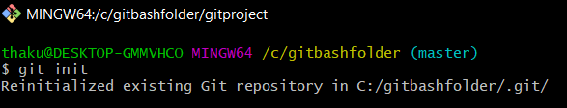  
  
(ii) **Config** commands:   
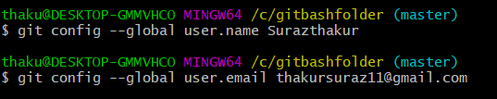

**Task 2: Open gitbash and clone the contents from the remote repository**  
(i)  
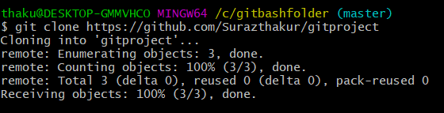  
  
(ii) show the cloned folder in the local repository  
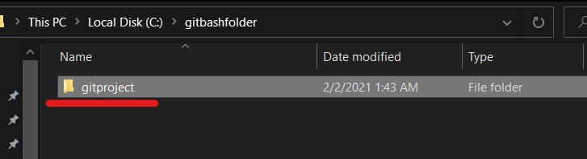  
  
  
  
  
**Task 3: Create a file in the local space and push it to the Remote repository**  
(i) **add**   
  
  
(ii) **commit**   
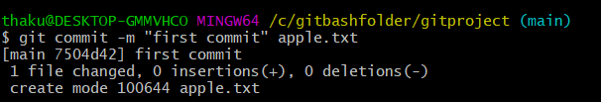  
  
(iii) **push**  
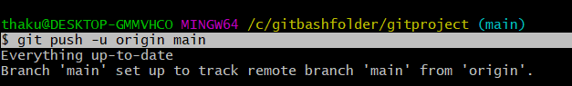  
  
(iv) show the file which is pushed to the remote repository  
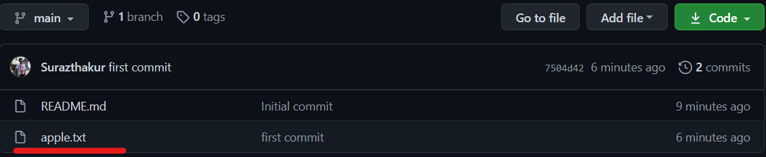

**Task 4: Branching and Merging**  
**Git Branching:**  
a. **git branch**  
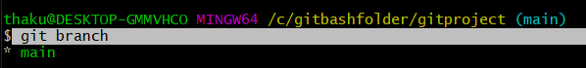  
  
  
b. **git branch branchname**  
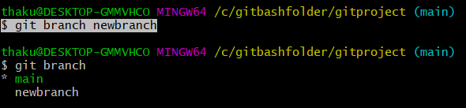  
  
  
c. **git checkout branchname**  
  
  
  
d. **git merge branchname**  
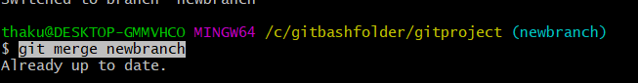  
  
  
e. **git branch -d branchname**  
  
  
  
f. **git branch -D branchname**  
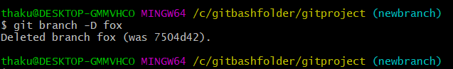  
  
  
g. **git checkout -b branchname**  
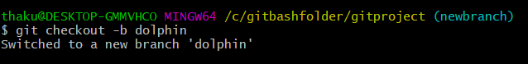  
  
  
h. **git log**  
